**Linux**

**1.What is Linux?**

Linux is an open-source operating system like other operating systems such as Microsoft [Windows](https://www.javatpoint.com/windows)

, Apple Mac OS, iOS, Google android, etc. An operating system is a software that enables the communication between computer hardware and software. It conveys input to get processed by the processor and brings output to the hardware to display it. This is the basic function of an operating system. Although it performs many other important tasks, let's not talk about that.

**2.Why use Linux?**

Linux makes very efficient use of the system's resources. Linux installation can be customised for users and for specific hardware requirements. The installation procedure is very flexible, and allows users to choose the modules they want to install.

Linux makes it easy for developers to deliver apps and easy for users to install those applications.

**Structure Of Linux Operating System:**

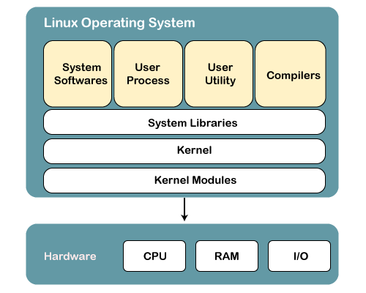

An operating system is a collection of software, each designed for a specific function.

Linux OS has following components:

**1) Kernel**

Linux kernel is the core part of the operating system. It establishes communication between devices and software. Moreover, it manages system resources. It has four responsibilities:

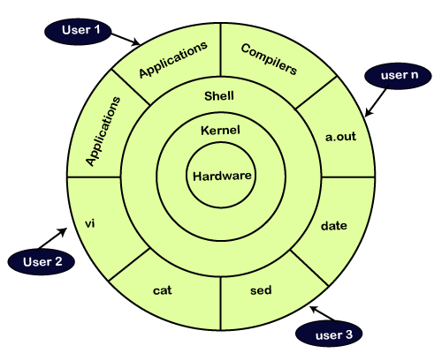

* **device management:** A system has many devices connected to it like CPU, a memory device, sound cards, graphic cards, etc. A kernel stores all the data related to all the devices in the device driver (without this kernel won't be able to control the devices). Thus kernel knows what a device can do and how to manipulate it to bring out the best performance. It also manages communication between all the devices. The kernel has certain rules that have to be followed by all the devices.
* **Memory management:** Another function that kernel has to manage is the memory management. The kernel keeps track of used and unused memory and makes sure that processes shouldn't manipulate data of each other using virtual memory addresses.
* **Process management:** In the process, management kernel assigns enough time and gives priorities to processes before handling CPU to other processes. It also deals with security and ownership information.
* **Handling system calls:** Handling system calls means a programmer can write a query or ask the kernel to perform a task

**2) System Libraries**

System libraries are special programs that help in accessing the kernel's features. A kernel has to be triggered to perform a task, and this triggering is done by the applications. But applications must know how to place a system call because each kernel has a different set of system calls. Programmers have developed a standard library of procedures to communicate with the kernel. Each operating system supports these standards, and then these are transferred to system calls for that operating system.

The most well-known system library for Linux is Glibc (GNU C library).

**3) System Tools**

Linux OS has a set of utility tools, which are usually simple commands. It is a software which GNU project has written and publish under their open source license so that software is freely available to everyone.

With the help of commands, you can access your files, edit and manipulate data in your directories or files, change the location of files, or anything.

**4) Development Tools**

With the above three components, your OS is running and working. But to update your system, you have additional tools and libraries. These additional tools and libraries are written by the programmers and are called toolchain. A toolchain is a vital development tool used by the developers to produce a working application.

**5) End User Tools**

These end tools make a system unique for a user. End tools are not required for the operating system but are necessary for a user.

Some examples of end tools are graphic design tools, office suites, browsers, multimedia players, etc.

Linux Distributions List

There are on an average six hundred Linux distributors providing different features. Here, we'll discuss about some of the popular Linux distros today.

1) Ubuntu

It came into existence in 2004 by Canonical and quickly became popular. Canonical wants Ubuntu to be used as easy graphical Linux desktop without the use of command line. It is the most well known Linux distribution. Ubuntu is a next version of Debian and easy to use for newbies. It comes with a lots of pre-installed apps and easy to use repositories libraries.

Earlier, Ubuntu uses GNOME2 desktop environment but now it has developed its own unity desktop environment. It releases every six months and currently working to expand to run on tablets and smartphones.

2) Linux Mint

Mint is based on Ubuntu and uses its repository software so some packages are common in both.

Earlier it was an alternative of Ubuntu because media codecs and proprietary software are included in mint but was absent in Ubuntu. But now it has its own popularity and it uses cinnamon and mate desktop instead of Ubuntu's unity desktop environment.

3) Debian

Debian has its existence since 1993 and releases its versions much slowly then Ubuntu and mint.

This makes it one of the most stable Linux distributor.

Ubuntu is based on Debian and was founded to improve the core bits of Debian more quickly and make it more user friendly. Every release name of Debian is based on the name of the movie Toy Story.

4) Red Hat Enterprise / CentOS

Red hat is a commercial Linux distributor. There products are red hat enterprise Linux (RHEL) and Fedora which are freely available. RHEL is well tested before release and supported till seven years after the release, whereas, fedora provides faster update and without any support.

Red hat uses trademark law to prevent their software from being redistributed. CentOS is a community project that uses red hat enterprise Linux code but removes all its trademark and make it freely available. In other words, it is a free version of RHEL and provide a stable platform for a long time.

5) Fedora

It is a project that mainly focuses on free software and provides latest version of software. It doesn't make its own desktop environment but used 'upstream' software. By default it has GNOME3 desktop environment. It is less stable but provides the latest stuff.

Choosing a Linux Distro

|  |  |
| --- | --- |
| **Distribution** | **Why To Use** |
| UBuntu | It works like Mac OS and easy to use. |
| Linux mint | It works like windows and should be use by new comers. |
| Debian | It provides stability but not recommended to a new user. |
| Fedora | If you want to use red hat and latest software. |
| Red hat enterprise | To be used commercially. |
| CentOS | If you want to use red hat but without its trademark. |
| OpenSUSE | It works same as Fedora but slightly older and more stable. |
| Arch Linux | It is not for the beginners because every package has to be installed by yourself. |